Adopt a Missionary – Ministry Support Needs
DECEMBER 2024
IMM USA – BOLIVIA & PERU Missionaries (62% funded)
TOTALS: $ 2,550 (100%); $ 1,913 (Incoming- 75%); $ 637 p.m. Needed – 25%

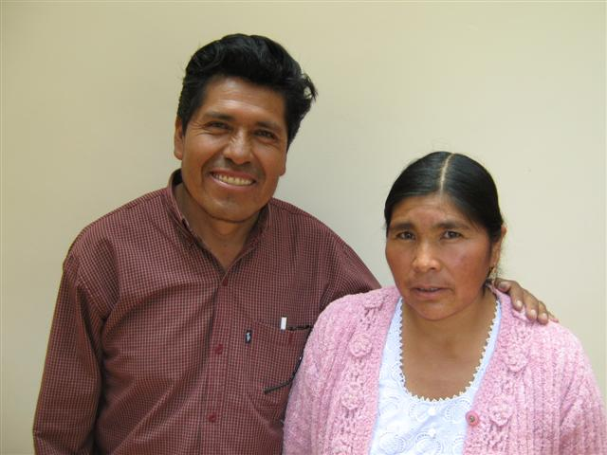
1) FIELD – BOLIVIA
Nicolas & Beatriz Ajhuacho –
Evangelism/Church Work - COCHABAMBA

The first IMM USA missionaries - began serving in 1995 - 29 YEARS WITH IMM

“God has called us to share Christ’s love with miners.”

Support Required $350 pm FULLY FUNDED PTL
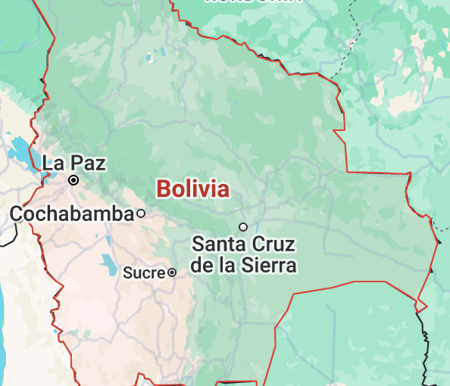

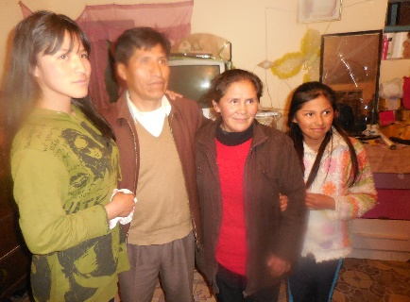
2) FIELD - BOLIVIA

Eugenio & Maida Nina –

5 YEARS WITH IMM

Evangelism/Church Planting – LLALLAGUA - TIN MINING
Church Leader – represents miners in a Cooperative
Saved at an Open-Air meeting in Llallagua. He has led one church, and planted a second one. Former miner, Eugenio ministers underground to his former co-workers.
Support Required $200 pm FULLY FUNDED PTL

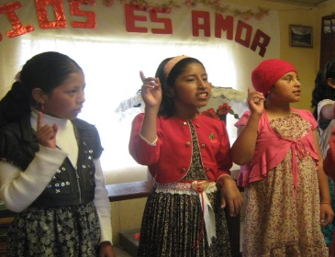
3) FIELD – BOLIVIA
Horita Feliz Ministry - CATAVI
300 - 400 Children
Led by Arminda Mamani and Elisa Flores
20 YEARS WITH IMM
TIN MINING
Weekly ministry to three children’s groups, led by Elisa Flores and Arminda Mamani - Worship, Bible Teaching, and Witnessing to families – about 370 children involved.
SUPPORT REQUIRED - $ 250 PM
FULLY FUNDED - PTL

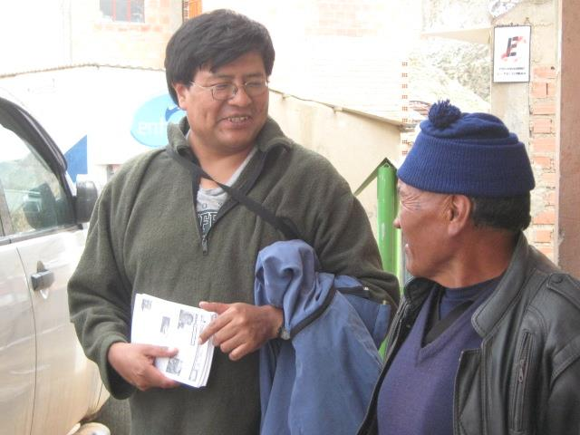
4) FIELD – BOLIVIA
Ruben Paco – Field Coordinator – La Paz
20 YEARS WITH IMM

Nothing could protect me from the mercy of God flowing through the prayers of my friends.
Ruben travels extensively in Bolivia to encourage, train and oversee IMM workers.
Ruben interacts with a miner in Potosi, Bolivia

Support Required $ 750 pm Support Received $ 413 pm Shortfall $ 337 pm

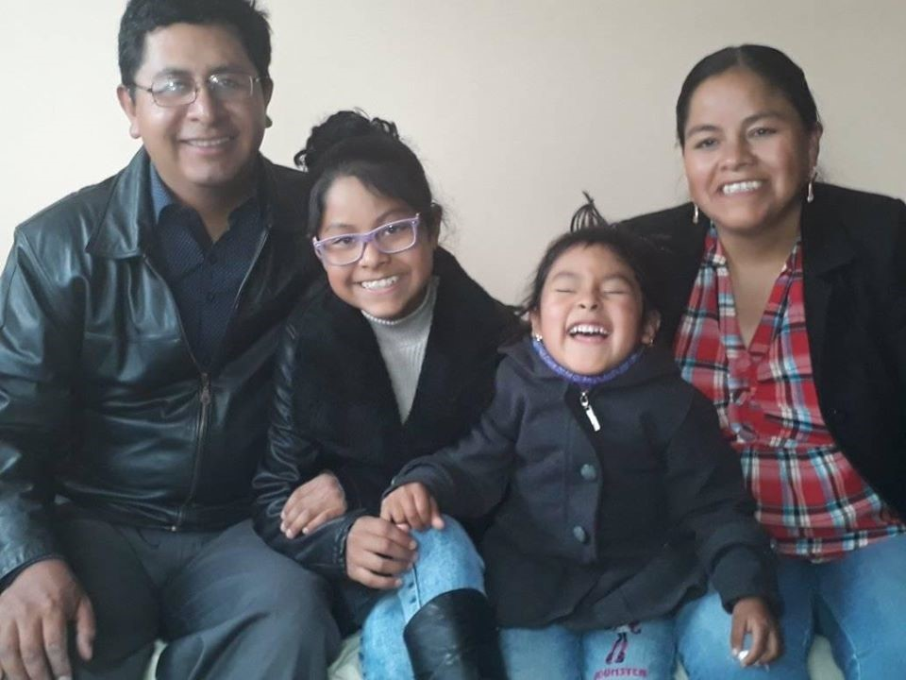
5) FIELD – BOLIVIA
Andres & Elma Negretty– Itinerant Pastor

15 YEARS WITH IMM

Home: Uncia, Northern Potosi, Bolivia
TIN MINING

Itinerant missionaries to 20 churches in two regions - organizes campaigns, discipleship programs…travels extensively in a 1995 Toyota RAV 4.

Support Required $400 pm
Support Received $100 pm Shortfall $ 300 pm

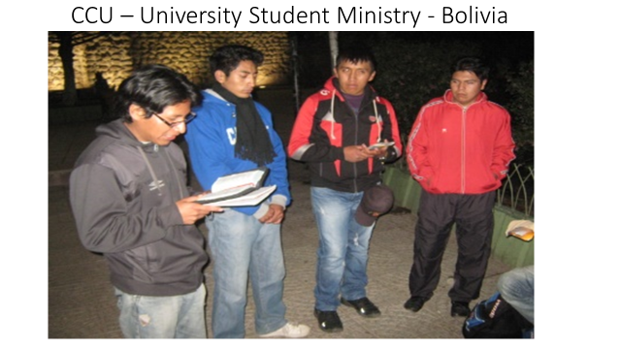
6) FIELD – BOLIVIA
CCU University Ministry
Potosi, Oruro, Llallagua, Catavi
University students meet to study God’s Word and witness to their fellow students – At 3 universities. Ministry on a temporary hold.
Previously supported them with $ 200 pm. NO WORKERS AT PRESENT

IMM USA - PERU Missionaries
7) FIELD – PERU
Rene Churata – Evangelism & Church Work
ORCOPAMPA – GOLD MINING

25 YEARS WITH IMM

Orcopampa (13,000’ elevation) – 3000 gold miners - evangelism, tracts, children, TEE discipleship. “I felt very sinful and knelt before the Lord, crying bitterly for about 30 minutes. The Lord Jesus came into my heart and I promised to serve Him from that day, the 1st of April in 1978.

Support Required $ 200 pm FULLY FUNDED – PTL

8) FIELD - PERU
Roberto Masca – Evangelism & Church Work
SALINAS AREA – 4 CHURCHES – SALT & BORAX
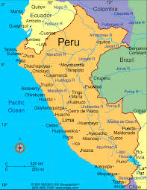
20 YEARS WITH IMM

Traveled 150 miles to a convention, heard God’s message, and “it went to my heart like an arrow.” Ministers in Tarucani, Condori – 12,000 ‘ elevation – several small remote mining villages.

Support Required $ 200 pm FULLY FUNDED PTL

9) FIELD – PERU

Santos & Teodocia Valero –

Field Coordinator – Arequipa

Supervises the ministries of Rene Churata and Roberto Masca, travels with them, and holds meetings with them in Arequipa. Met the Lord through his parents in 1979 and was baptized the same year. Oversees IMM Peru. Senior pastor in Arequipa.

Support Required $ 200 pm FULLY FUNDED – PTL

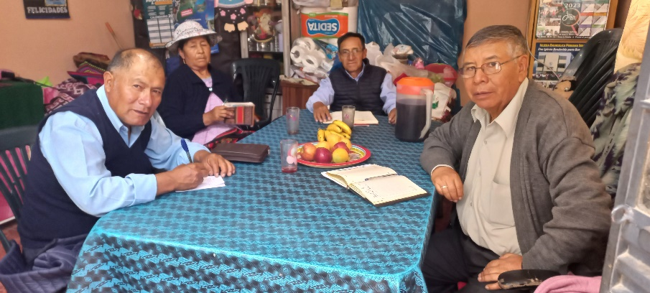
IMM Peru Team – Prayer, Fellowship, Planning

